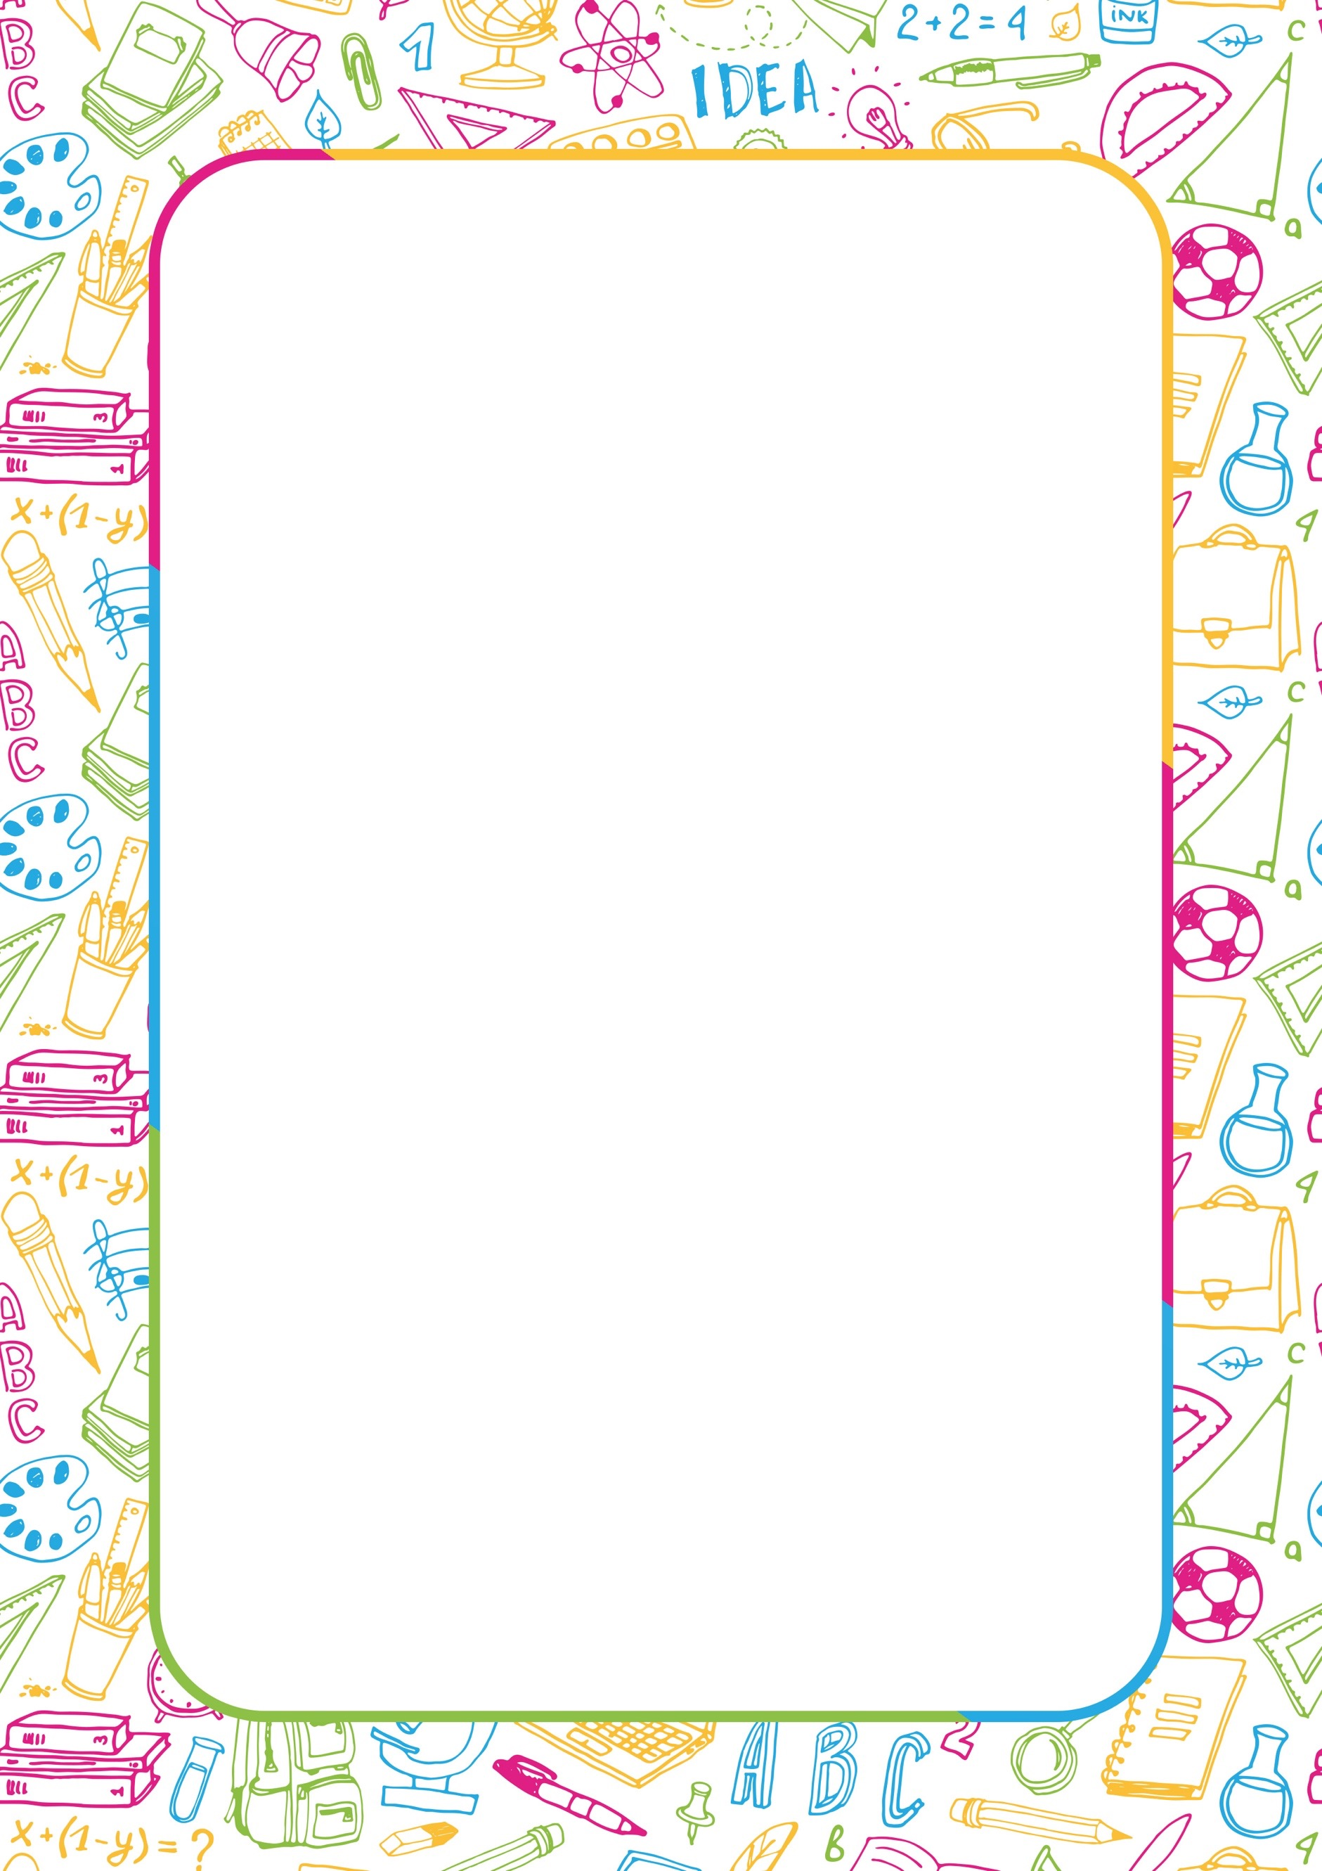

My Name: | Click or tap here to enter text.
I like to be known as: | Click or tap here to enter text.
My Date of Birth: | Click or tap to enter a date.
Today’s Date: | Click or tap to enter a date.
I was helped by: | Click or tap here to enter text.

My Relationships

These are the important people in my life (This can include family, friends, pets and other adults).

My Family  Click or tap here to enter text. | Click on the box below to add a picture of yourself or  something that represents you. |  |  | My Friends  Click or tap here to enter text.
Important People in School  Click or tap here to enter text. |  |  |  | Other Important People  Click or tap here to enter text.

My Personal Profile

I like |  | I don’t like
Click or tap here to enter text. |  | Click or tap here to enter text.

What I am good at and proud of:
Click or tap here to enter text.

My hobbies and interests:
Click or tap here to enter text.

How I communicate and listen and understand:
This can include progress with speech and language skills, do other people understand you when you are talking, the way you communicate with people. Also, what support do you need to understand requests or remember information.
Click or tap here to enter text.

How I get on with people:
How do you get on with other children? Do you often prefer to play or do things on your own? How do you get on with your family, other adults, and teachers?
Click or tap here to enter text.

What people like about me and what I can do well:
Tell us about what people like most about you. This can include what people say you’re good at, how you get along with others, how you interact.
Click or tap here to enter text.

What is important to me now:
This could include hobbies and interests, things you like or do not like, important activities or routines, important people, places or objects, social activities, health and wellbeing, communication, academic achievement, relationships.
Click or tap here to enter text.

What is important for me:
This could include important things people need to know about your health, behaviour, the way you communicate, how you want to be involved in making decisions. Do you struggle with managing your emotions or frustrations?
Click or tap here to enter text.
My goals, aspirations, hopes and dreams for the near future (next 12 months):
This can include things you’d like to achieve in the next year such as achieve school targets, learn a new hobby, join a new club, make new friends, become healthier or more active etc.
Nursery/School/College
Click or tap here to enter text.

Home
Click or tap here to enter text.

Family & Relationships
Click or tap here to enter text.

Health & Social
Click or tap here to enter text.

Communication
Click or tap here to enter text.

My goals, aspirations, hopes and dreams for the far future:
This can include things in the far future such as if you’d like to attend college/university/an apprenticeships, being more independent, starting a new hobby, what you’d like to do as a job, where you would like to live, have a family, have your own home etc.
School/College/University/Apprenticeships/Job
Click or tap here to enter text.

Home
Click or tap here to enter text.

Family & Relationships
Click or tap here to enter text.

Health & Social
Click or tap here to enter text.

Communication
Click or tap here to enter text.
How best to support me:
Tell us what support you feel you would benefit from to help you achieve your goals, aspirations, hopes and dreams. Is there anything you need to be able to make things easier in school/college? Do you need help in any other areas?
Click or tap here to enter text.

Other things I’d like you to know about me:
This section is for you to tell us anything you think we may have missed that you’d like us to know.
Click or tap here to enter text.

Signature of the young person: | Click or tap here to enter text.
Date signed: | Click or tap to enter a date.
Signature of the supporting adult: | Click or tap here to enter text.
Date signed: | Click or tap to enter a date.

